Silicon croft

Employee Handbook

# How to create a post on the website

## Logging in to the WordPress dashboard

Before we can create the post we will have to log in to the WordPress dashboard for our website. We can do this by navigating to <http://www.webcomputing.co.uk/project5/wp-login.php/> in a web browser and we should see a webpage similar to the one shown below.

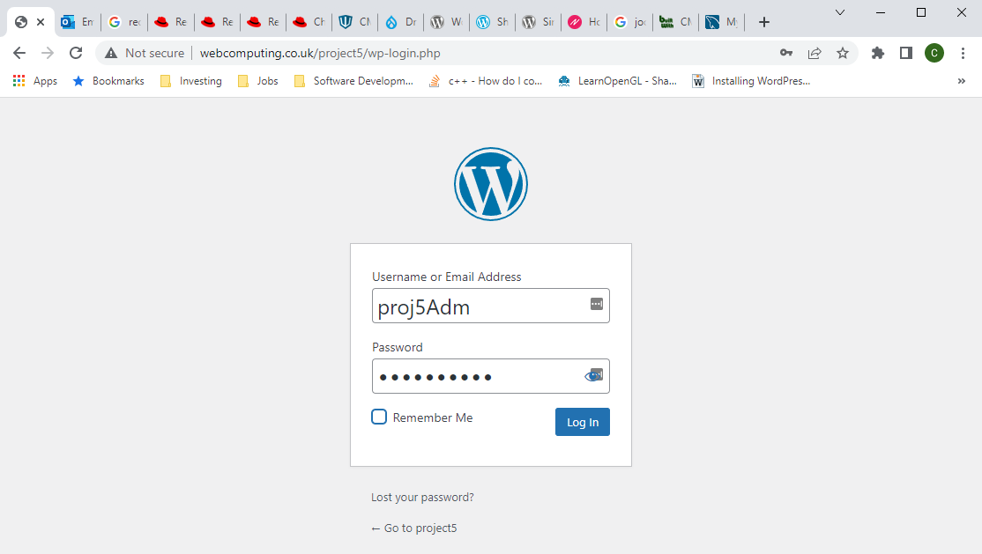

You will now enter the login details you have been provided by your team leader/manager and click the log in button. You should then be brought to the WordPress dashboard as shown below.

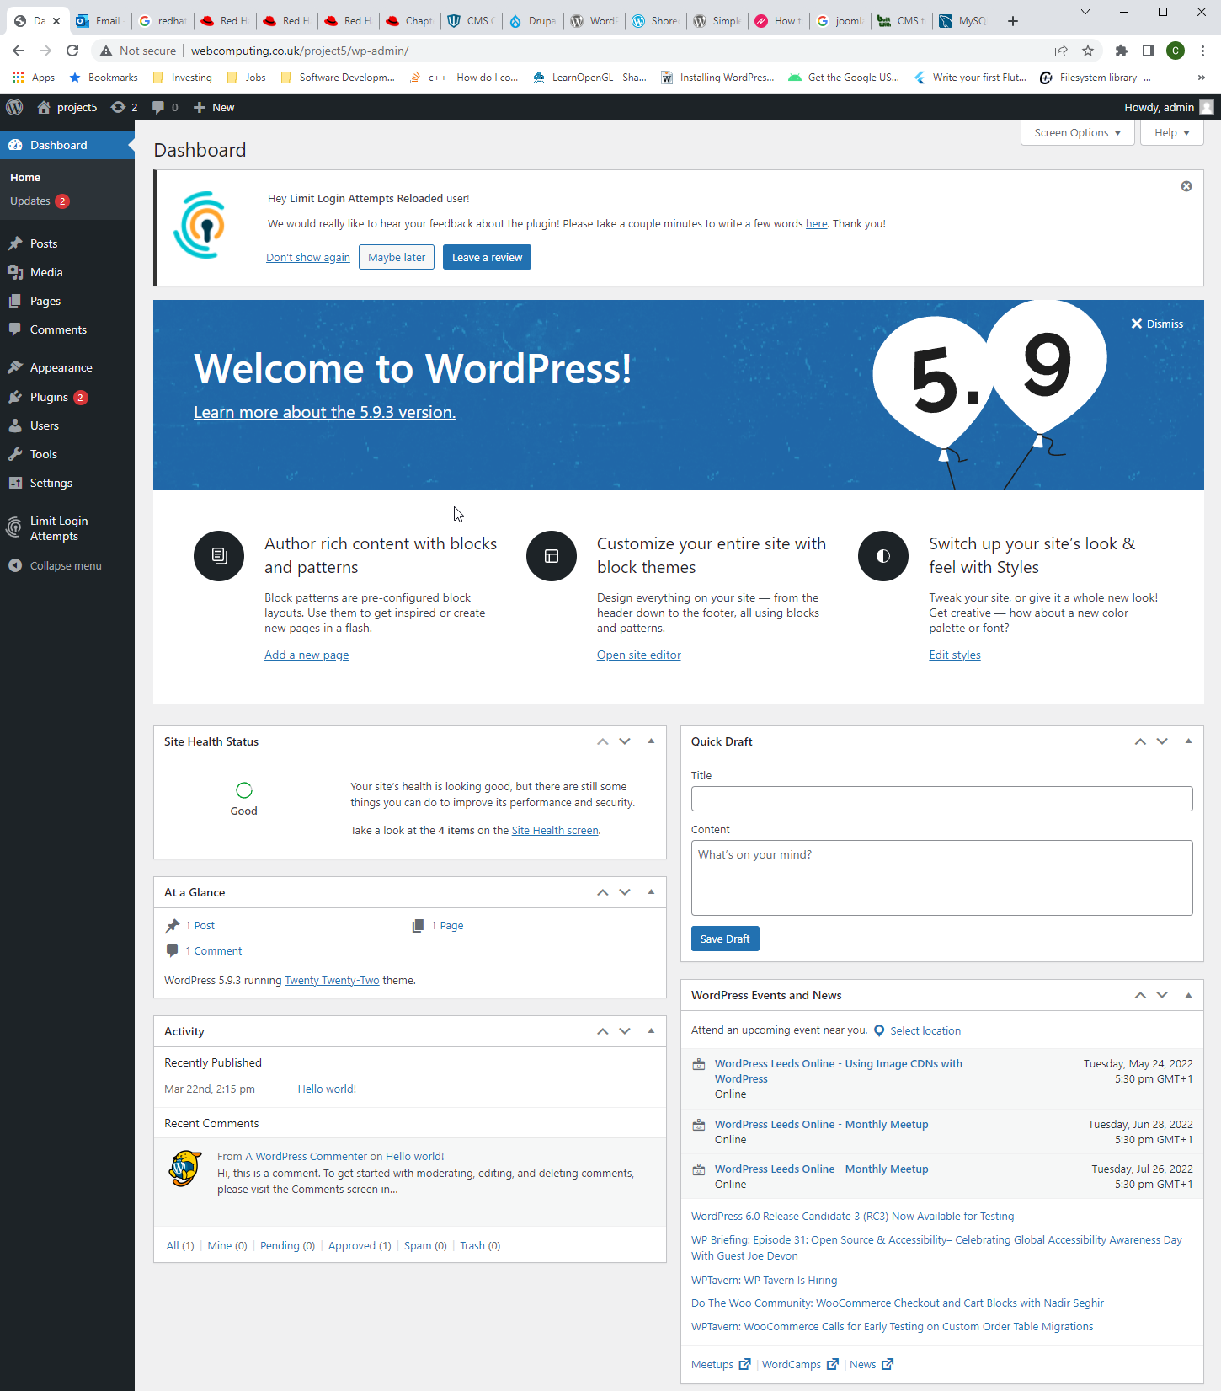

## Creating our blog post

Now that we are logged in we can create our blog post! We will start by hovering over the posts option in the toolbar on the left of the page and then we will click on the add new sub-option. This will load the post editor with a blank post as shown below.

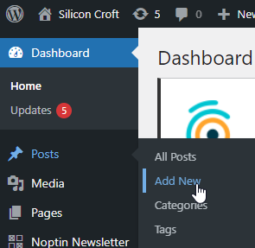

Now we can click in the add title textbox at the top of the editor and type out a title for our new blog post.

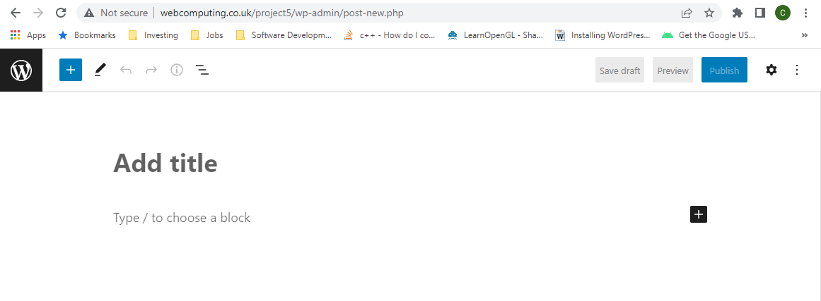

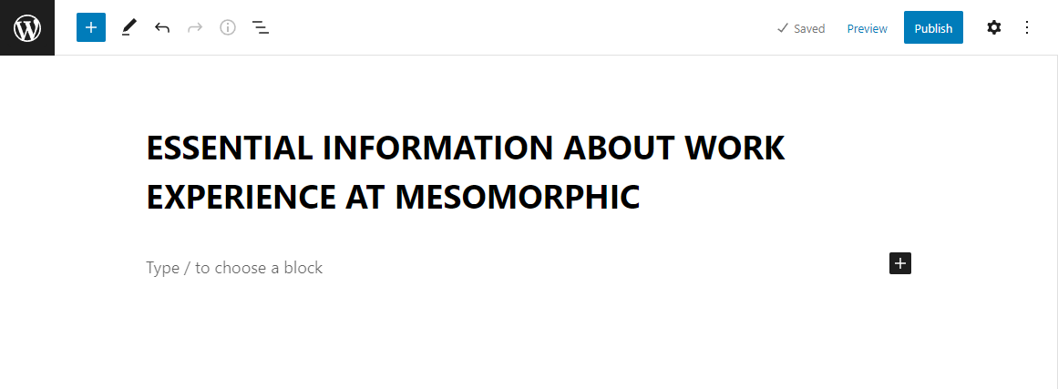

Next we are going to add an image to the post by going to a file browser where our image is located and clicking copy then selecting the ‘Type / to choose a block’ textbox, right-clicking and selecting paste.

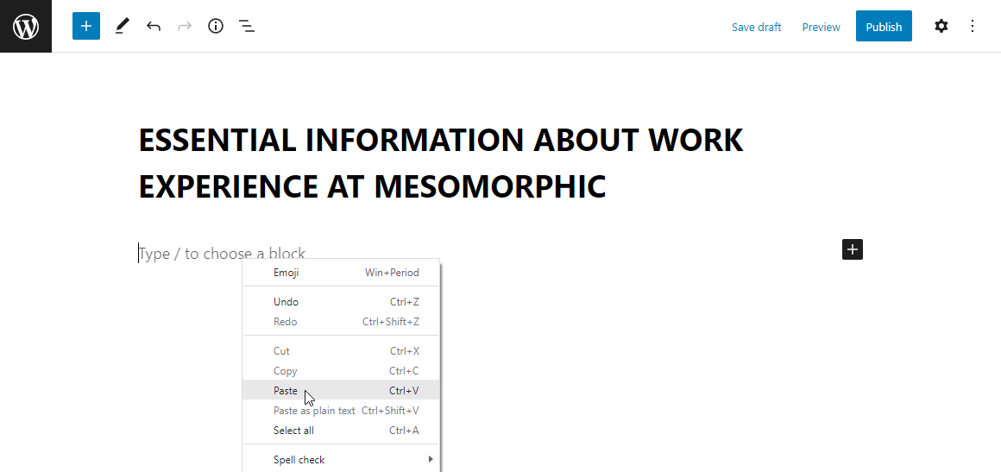

And there we go it’s as easy as that, WordPress will automatically select the add caption textbox as shown and we can add a caption now if we want to, otherwise we can just click below the add caption textbox on the empty webpage.

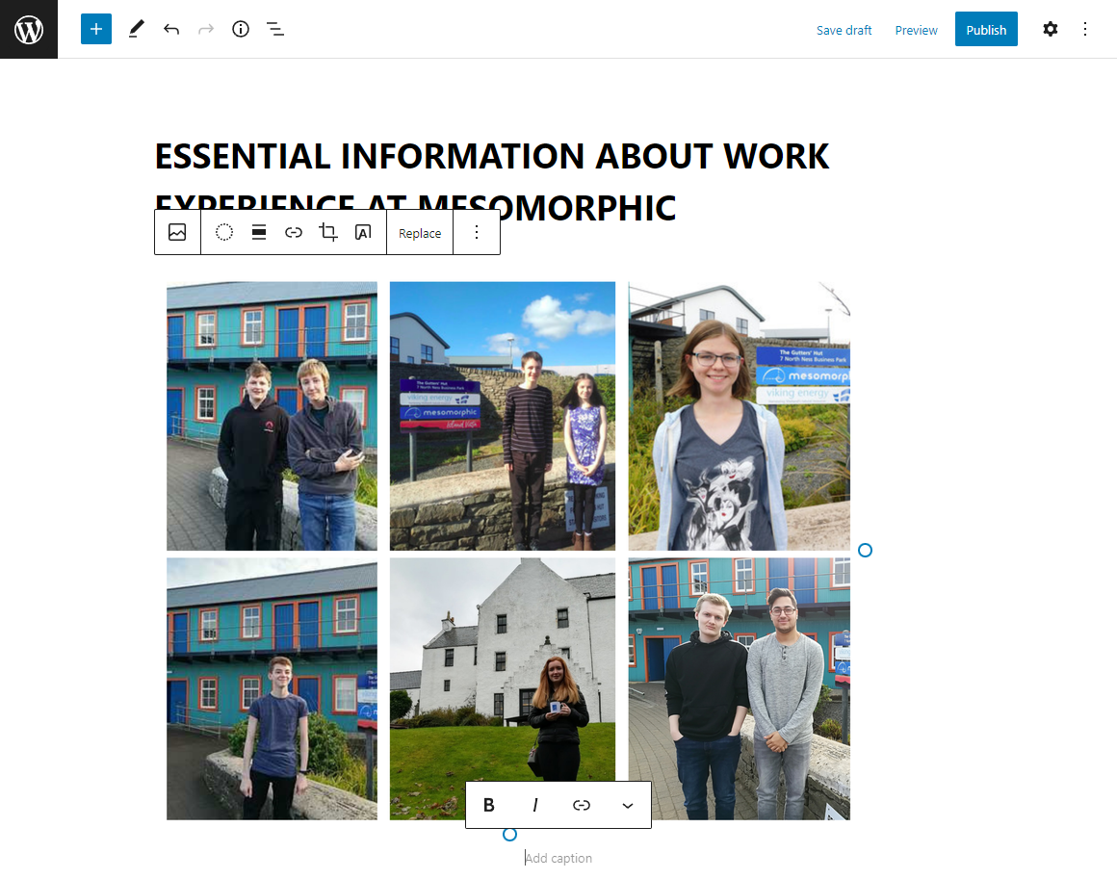

Great! Now we want to add some text so we will select the ‘Type / to choose a block’ textbox underneath the image and start typing. To create separate paragraphs all you have to do is hit enter at the end of a paragraph as you normally would do when writing.

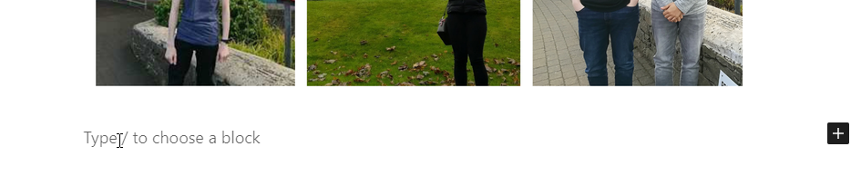

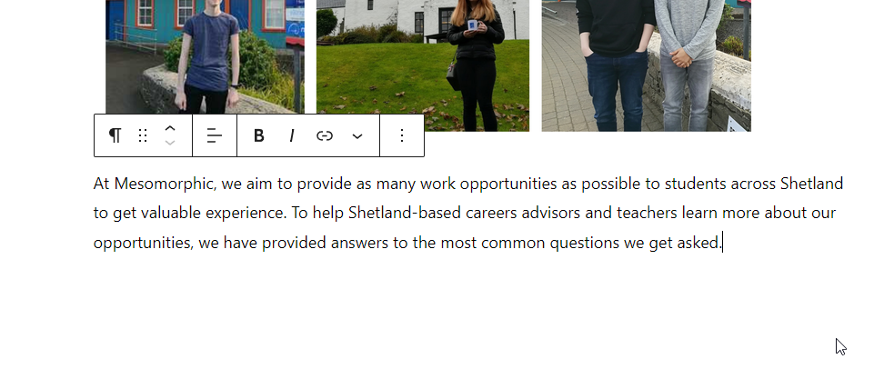

Great so that’s the basics of creating a blog post. There are more tools available to you by clicking on the little plus icon and browsing through the many ‘Blocks’ that WordPress provides, however, these are beyond the scope of this handbook but feel free to experiment. We will now add another image and some text to finish off this post.

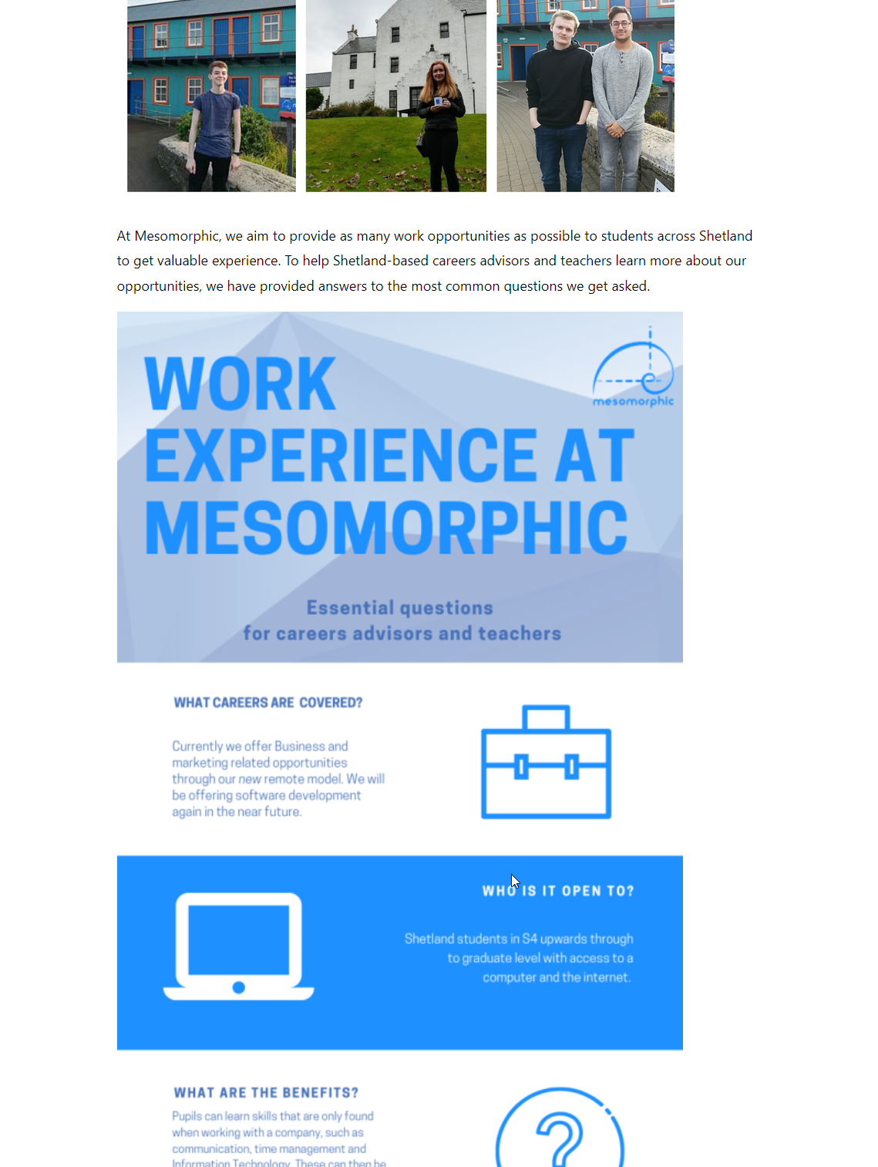

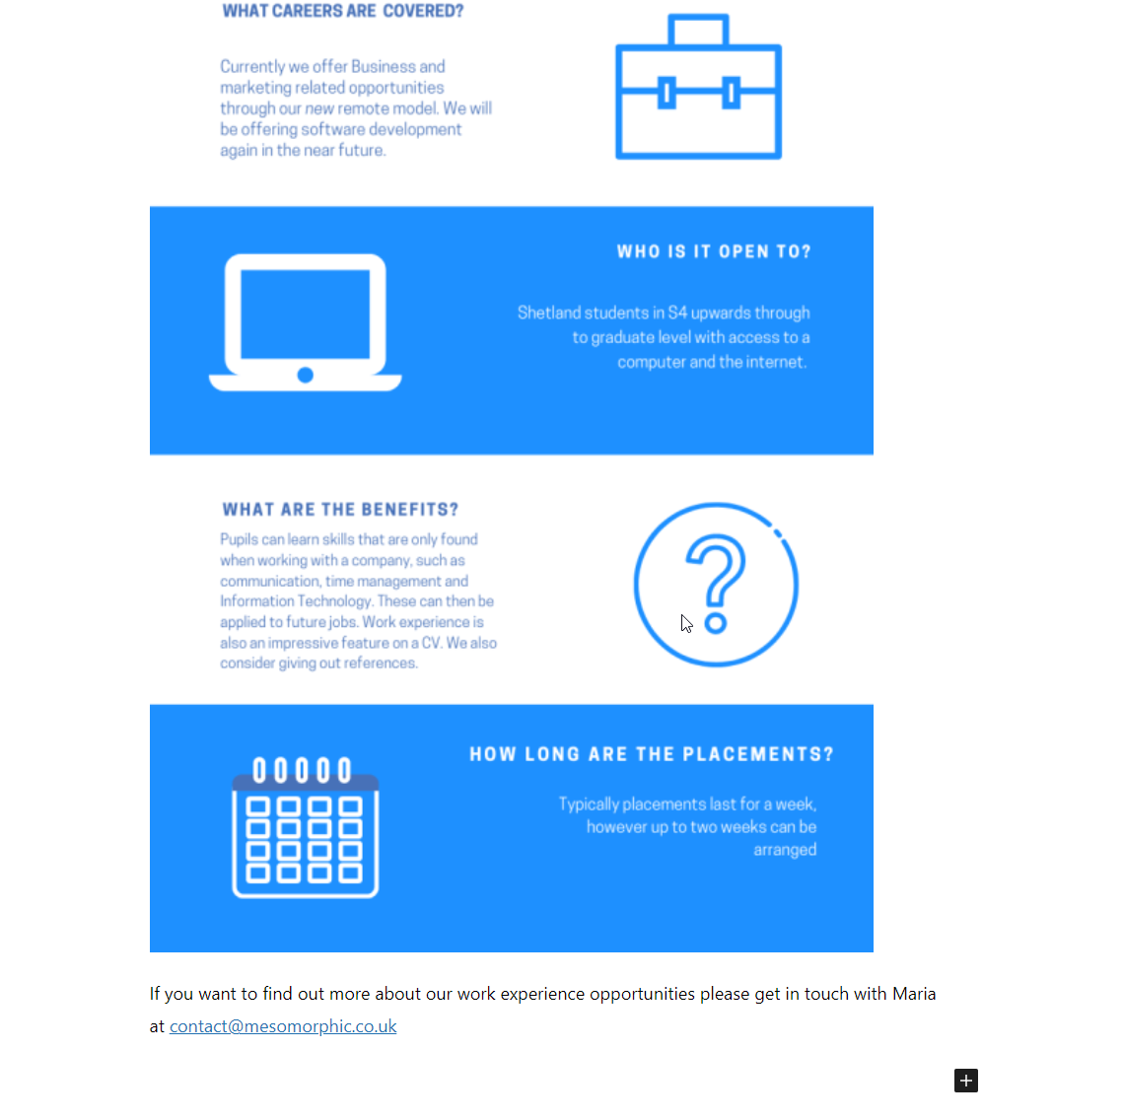

That’s our post finished, it’s a fairly simple post but they can be as small or large as you want. We can hit publish and then publish again to make the post appear on the website!



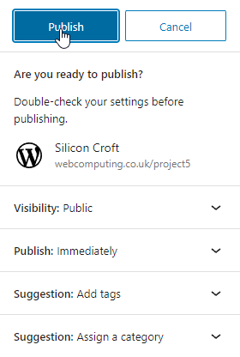

That’s it! Our post will now be live on the website and can easily be found by going to the Blog page and looking at the list of blog posts there. If you want then you can stop here and logout of WordPress, however, we normally would want to notify our subscribers about the new blog post for them to come and see. If we are doing this we will click the copy button as shown so that we can paste a link to the blog post in our email.

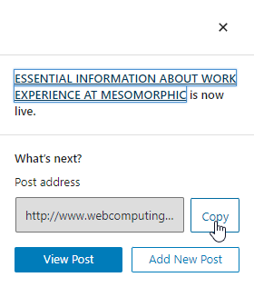

## Sending an email to our subscribers about the new post

To begin we will go back to the WordPress dashboard and then click on Noptin Newsletter from the toolbar on the left which will take us to Noptin Newsletter’s dashboard.

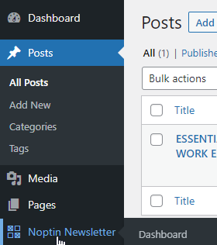

Now we will click the send them an email link as shown

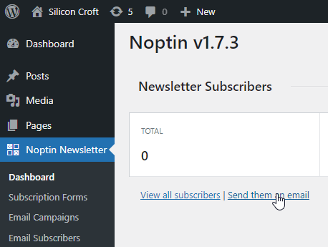

And we will choose to send the email to our Noptin Subscribers.

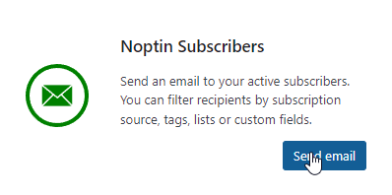

Near the bottom in the template form we can choose the heading for our email.

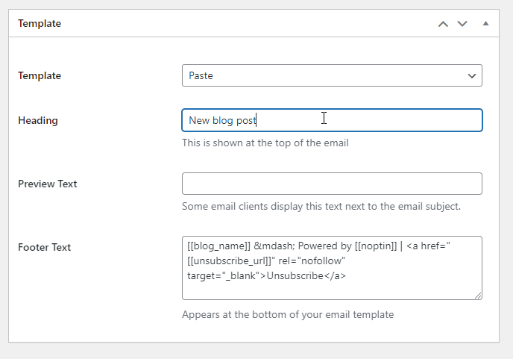

Then, we will create the emails contents and paste our link somewhere for the user to follow.

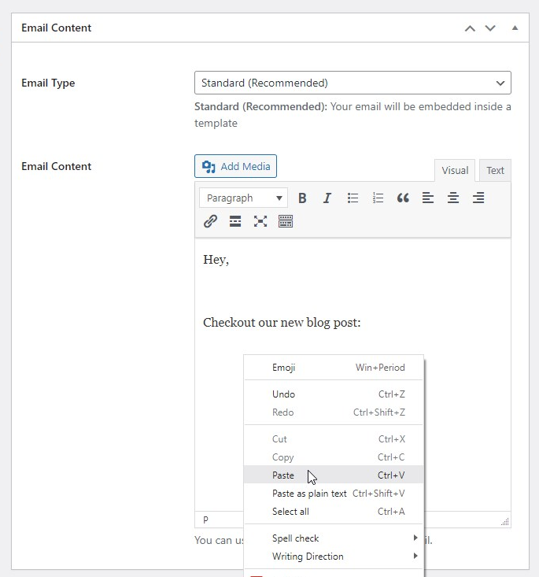

Now the email is ready and we can click send to send it to all of our Noptin subscribers.

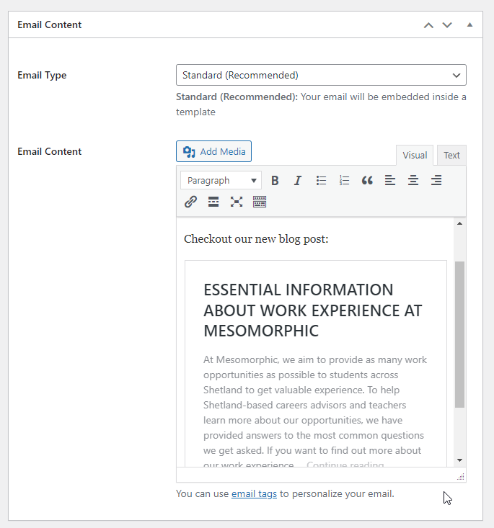

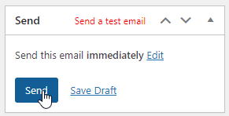

Great! Our email will now be sent out to all our subscribers! But wait, what if we’ve made a mistake! Well there’s nothing you can do about any emails that have already been sent as the users will already have the emails stored in their inboxes, however you can stop Noptin from sending any more emails out by clicking the stop link as shown below.

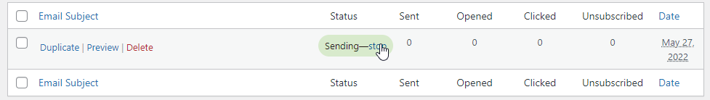

Well Done! You have successfully created your first post and sent an email to all your subscribers letting them know that it has been created! There is a lot more to making content in WordPress and using the Noptin Plugin which with a little exploration and experimentation you can take advantage of but that is outside of the scope of this short handbook.